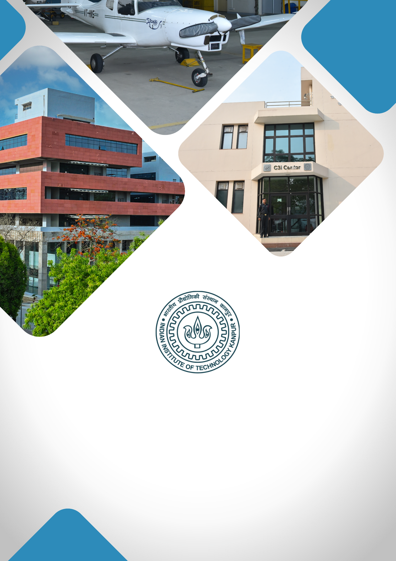

**Net-Zero IIT Kanpur: Creating pathway for Net-Zero India**

**TABLE OF CONTENTS**

1. **About IIT Kanpur**
2. **Institutional Vision**
3. **Project Title**
4. **Executive Summary**
5. **Background & Rationale / Motivation**
6. **Project Objectives**
7. **Expected Outcomes**
8. **Expected Impact**
9. **Milestones & Implementation Timeline**
10. **Financial Budget**
11. **Team Involved / Key Faculty Members**

**ABOUT IIT KANPUR**

**Indian Institute of Technology Kanpur**, established in 1959, is one of the premier institutions established by the Government of India. The aim of the Institute is to provide meaningful education, conduct original research of the highest standard, and provide leadership in technological innovation. The Institute has gained a legendary reputation in the country through its academic, social, and economic contributions. The combined record of its past and present faculty and students along with the alumni spread across the world is awe-inspiring.

From the start, the students have been provided education with a strong emphasis on the fundamentals of science and engineering and their application in the field of study. Subsequently, programs in humanities, management, and several interdisciplinary programs like design, environmental engineering and management, material sciences, nuclear engineering and technology, and photonic sciences and engineering programs were started. The education imparted to the students has stood by them even as they acquired new skills and knowledge during their professional careers.

IIT Kanpur continues to be a much sought-after destination for UG and PG studies. In the 65 years of its existence, over 43,000 students have graduated from the Institute. The alumni of IIT Kanpur have made their alma mater proud through their achievements and contributions in diverse fields like engineering, academia, business, entrepreneurship, and public service.

The Institute today has close to 600 full-time faculty members and all of them have earned their degrees from the top universities in the world. The Institute faculty members have often been bestowed with prestigious national honours as listed below:

|  |
| --- |
| Padma Shri |
| Infosys Prize (Infosys Science Foundation) |
| J C Bose Fellowship |
| Shanti Swarup Bhatnagar Prize for Science & Technology |
| Fellow, Indian National Science Academy (INSA), New Delhi |
| Fellow, Indian Academy of Sciences (IAS), Bangalore |
| Fellow, Indian National Academy of Engineering (INAE), New Delhi |
| Fellow, The National Academy of Sciences, India (NASI), Allahabad |
| Humboldt Research Award |
| TWAS Prize |
| Wellcome Trust/India Alliance Early Career/Intermediate/Senior Fellowship |
| Tata Innovation Fellowship |

The Institute has a large pool of academic resources spanning 19 departments, 25 centers, and 3 Interdisciplinary programs in all engineering, science, design, humanities, and management disciplines. It has a student strength of more than 9000 across all programs.

IIT Kanpur has always laid strong emphasis on new academic initiatives that will allow the Institute to broaden its academic repertory and create an impact in academia and society. Some of these initiatives include the Department of Sustainable Energy Engineering and the Department of Cognitive Science which were established in the year 2020.

**INSTITUTIONAL VISION**

***"To create, disseminate, and translate knowledge in science, engineering, and allied disciplines that will best serve society."***

1. **Developing Technologies that Solve Real-World Problems:** Prioritising research and development that address critical societal challenges, translating innovations into solutions with high-TRL (Technology Readiness Level) technologies. The goal is to establish an Office of Translational Research within the Directorate for strategic guidance, funding support, industry connections, and information on government and industry needs.

**Major focus areas:**

* **Large-Scale AI Deployment**: Implementing AI solutions on a wide scale, focusing on impactful applications for government and industry sectors, including public grievance redressal and fraud detection.
* **MedTech:** Making healthcare accessible and affordable through cutting-edge research, device innovation, and medical training with the **Mehta Family Center**, **MedTech IITK**, and the **Gangwal School of Medical Sciences & Technology**.
* **Cybersecurity:** With **C3iHub**, focused on developing advanced solutions, supporting startups, and offering specialised training for critical cybersecurity needs.
* **Unmanned Aerial Vehicle (UAV) Technology**: Advancing UAV technology with a focus on defence, humanitarian, and disaster relief applications, and providing affordable testing facilities to promote industry growth.
* **Sustainability:** Positioning IIT Kanpur as a leader in sustainable development through technologies and initiatives led by the **Kotak School of Sustainability**, the **Chandrakanta Kesavan Centre** **for Energy Policy and Climate Solutions**, and the **Department of Sustainable Energy Engineering**.

1. **Elevating R&D Excellence:** Focus on recruiting top talent, creating state-of-the-art facilities, securing substantial research grants, and maintaining a balance between research quality and quantity.
2. **Enhancing Teaching Quality:** Achieving leadership inhigh-quality education by establishing a Centre for Teaching Excellence, developing courses in soft skills and technical writing, and introducing faculty career paths that focus on research, translational projects, or teaching.
3. **Enhancing Student Life and Campus Infrastructure:** Upgrading existing hostels and constructing new ones to accommodate growing student numbers. Developing state-of-the-art infrastructure within the campus.

**“Net-Zero IIT Kanpur: Creating pathway for Net-Zero India”**

**EXECUTIVE SUMMARY**

Under the Paris Agreement, India committed to cut emissions intensity against GDP by 45% by 2030, compared to 2005. In COP26, it amended to add a new goal: to achieve net-zero emissions by 2070. In addition to other sectors, educational institutes also play a significant role in GHG emissions of any country; owing to their vast landmass, resources and residents. In addition to the resource consumption the sector also houses and educate next generation leaders and society builders. The aim of the project is to convert IIT Kanpur in to a Net-Zero campus and working with a bigger society to help India in it’s transition towards a successful Net-Zero journey.

**BACKGROUND & RATIONALE / MOTIVATION**

As the world makes its Net-Zero targets, with India announcing its target of becoming net-zero carbon country by 2070, it is imperative for all spheres of the society to contribute to this transition. Colleges and universities, who like any other organisation, contribute to carbon emissions through their operations and activities and therefore, they must align their growth trajectories with sustainable practices in general and net-zero goals in particular.

For a prestigious and continually expanding institute like IITK, pursuing net-zero goals and carbon neutrality is not only a conscientious choice but also a strategic necessity. Committing to net-zero goals allows IITK to position itself as a leader in the domain of carbon neutrality. Moreover, as IITK expands, proactively addressing issues of energy efficiency, waste management and water conservation averts imminent resource crises, and brings financial gains in the longer run.

The Institute has already started making efforts along these lines, with the establishment of the Department of Sustainable Energy Engineering, Kotak School of Sustainability, Chandrakanta Kesavan Center for Energy Policy & Climate Solution, The Centre for Enviromental Science & Engineering and Centers of Excellence (CoEs) in Artificial Intelligence (AI) for Sustainable Cities. It has also initiated several internal and external projects in this domain, such as:

* Estimation of institute’s carbon footprint and identifying critical points for reducing carbon footprint,
* Reduction of their 40 ton/day waste generated at the Cantonment Board, Lucknow that is currently going to landfills (MoU signed in 2024),
* Working with Kanpur municipality to help them handle ~ 1400 ton/day waste currently going to landfills.
* Working with Jhansi cantonment on net-zero buildings.

**PROJECT OBJECTIVES**

The overall objective is to make IIT Kanpur a carbon neutral campus by 2030. This involves understanding the current and projected IIT Kanpur campus’ overall carbon footprint, and devising and executing an optimised transition plan to achieve carbon neutrality by 2030.

For an Institute like IIT Kanpur, net-zero goals are epicentred around three primary “verticals” – energy, water and waste. Thus, the specific objectives are:

1. To understand electricity consumption patterns and create and execute an economically viable pathway to significantly reduce its carbon intensive energy footprint.
2. To understand water consumption patterns and related challenges and create and execute a road map for making IITK a net-zero water campus.
3. Strengthen the campus waste management system and become a zero-landfill waste campus.
4. Create a connected campus with accurate monitoring dashboards, both to keep us on track towards our goals, to create awareness and to remain sustainable.

**EXPECTED OUTCOMES**

Key expected outcomes are:

1. Become a near carbon neutral campus by 2030.
2. Improve energy efficiency of institute buildings by at least 30%
3. Transition from primarily fossil-fuel based campus to a renewable energy based campus
4. Establish an in-house waste management system to achieve zero-landfill waste by 2028.
5. Achieve net-zero water campus, by water conservation, optimized consumption and replenishment into ground sources by 2030.
6. Achieve ESG compliance, indicative of environmental, social and governance maturity, by 2035.

**PROPOSED IMPACT** (SOCIAL / SCIENTIFIC)

Some of the expected outcomes are:

1. Social: The knowledge base created will enable institute to play a nodal role in India’s journey towards Net-Zero 2070 goal. Specifically we can:
   1. Work in close co-ordination with Kanpur city, district and UP state administration to for a carbon-free, waste free and sustainable society.
   2. Hand-hold other universities and colleges in the state in this transition journey.
   3. Hand-hold other gated communities like army cantonments, PSUs in their journey towards Net-Zero.
2. Technical: Develop technical solutions for real world interventions, like:
   1. cost-effective solution for reducing running carbon footprint of existing infrastructure
   2. cost and carbon footprint optimized energy transition models for bulk users, discoms, cities, states.
   3. Off-grid renewable energy generation solutions with suitable storages and mini-grid.
   4. for waste segregation – both at source and later in the value chain
3. Economic:
   1. Create multiple start-ups
   2. Institute can be consultant to multiple organizations looking for this transition

**MILESTONES & IMPLEMENTATION TIMELINE**

|  |  |  |  |  |  |
| --- | --- | --- | --- | --- | --- |
| **DELIVERABLES/MILESTONE** | **Y1** | **Y2** | **Y3** | **Y4** | **Y5** |
| Creating a detailed plan for the whole project |  |  |  |  |  |
| Hiring Staff |  |  |  |  |  |
| Setting up the waste management facility |  |  |  |  |  |
| Building energy efficiency projects in first three buildings and central AC system |  |  |  |  |  |
| Building energy efficiency measures replicated in whole campus |  |  |  |  |  |
| Forming contracts for the renewable energy procurement |  |  |  |  |  |
| Setting up energy storage facility and grid upgradation |  |  |  |  |  |
| Upgrading the water extraction and supply facility |  |  |  |  |  |
| Establishing water reclamation network |  |  |  |  |  |
| Establishing water pipe line up to IIT Kanpur from Ganga Barrage |  |  |  |  |  |
| Create framework |  |  |  |  |  |

**BUDGET**

|  |  |
| --- | --- |
| Budget Head | Amount in  (INR) |
| Capital Expenditure (CAPEX) | |
| Building Modification Cost to make building’s energy efficient (IIT has > 5 lakh m2 of built-up area) | 70,00,00,000 |
| Civil Construction- for water conservation, reuse and replenishing ground water | 40,00,00,000 |
| For Laying out a dedicated pipe line from Ganga Barrage to IIT Kanpur | 35,00,00,000 |
| Electrical Equipment – for modifying substation for integration of renewable energy supply and putting storage (we plan to get solar and wind power in RESCO model) | 90,00,00,000 |
| Waste Management | 5,00,00,000 |
| Digital Infrastructure | 2,00,00,000 |
| Operational Expenditure (OpEX) | |
| Services and Consultancy | 2,00,00,000 |
| People Cost – 4-6 people team for 5 years | 3,00,00,000 |
| Other Expenses | |
| Contingency | 3,00,00,000 |
| TOTAL (INR) | 2,50,00,00,000 |

**TEAM INVOLVED / KEY FACULTY MEMBERS**

Faculty members are engaged from various departments, including the Kotak School of Sustainability, Department of Sustainable Energy Engineering, Department of Civil Engineering, Department of Computer Science, Department of Electrical Engineering, and Department of Biological Sciences and Bioengineering.

Key Research Area: Energy Transition Modelling, Smart Grid and Renewable Integration, Solar Photovoltaics, Wastewater Recycling and Reuse, Water and Wastewater Treatment, Energy-efficient Buildings, Electricity Markets, Modelling and Design of Electrical Energy Systems, Human Computer Interaction (Human-AI interaction, Tech for Good).